MARS SECURITY GUARDS COMPANY

22-C, SUITE # 2,1ST FLOOR,LANE-1COMMERCIAL, PHASE-V, D.H.A KARACHI

# Ref: Date:

### TO WHOM IT MAY CONCERN

It is certified that Mr. <Name> S/O <fname> has worked as a <designation> at Al. Falah Bank Karachi Saddar at MARS Security Guards Company Pvt. Ltd Karachi from <From> to   
<To>.

During this period, his services were found satisfactory. We wish him every success in his future life.

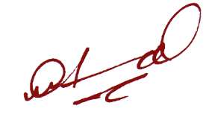

Security Officer